

NCICB

NCICB

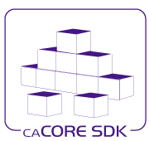
caCORE SDK
Securing SDK Generated System with
Grid Credentials

Version No: 0.2
Last Modified: 8/22/2008

Author: Satish Patel
Team: caCORE SDK
Client: National Cancer Institute - Center for Bioinformatics,
National Institutes of Health,
US Department of Health and Human Services

This document was prepared for
NCI Center for Bioinformatics, pursuant to the caCORE Software Development Kit (SDK)
Enhancement project.(REF: Solicitation No. S06-234).
Document History
Document Location
The most current version of this document is located in CVS under cacoresdk/Project/SDK v4.1/Development/Design

Revision History
Version Number | Revision Date | Author | Summary of Changes
0.1 | 8/20/08 | Satish Patel | Initial draft
0.2 | 8/22/08 | Satish Patel | Completed 1-8 from Kunal’s comment and 1-1 of Vijay’s comments. See below

Review
Name | Team/Role | Version | Date Reviewed | Reviewer Comments
Kunal Modi | Security Solutions Arch | 0.1 | 8/22/08 | 1. caGrid - change case  2 .backwards compatible  3. Limitation- Grouper is not supported  4. Recolor diagram boxes  5. Rename filters to HTTP filter  6. Rename Grid Login Service to include "Webapp"  7. See if the proper exception can be thrown indicating user does not have access rights for this service only  8. Include SyncGTS in design  9. Web service, RESTful and webapp all should take authentication service URL
Vijay Parmar | CSM Team Lead | 0.1 | 8/22/08 | 1. JAAS authentication service as parameter
Santhosh Garmilla | WebSSO Lead | 0.1 | 8/22/08

Related Documents
More information can be found in the following related documents:

Document Name
SECURING SDK’s REMOTE SERVICE USING caGrid’s GAARDS INFRASTRUCTURE
Contents
1 Introduction 7
1.1 Purpose 7
1.2 Intended Audience 7
1.3 Scope 7
1.4 Document Overview 7
1.5 Acronyms and Definitions 7
2 Background 8
3 Requirements 9
3.1 Business Requirements 9
3.2 Policy Requirements 9
3.3 caCORE Requirements 9
4 Business View 10
5 Design 12
5.1 SDK Generated Application’s Interfaces 12
5.2 SDK’s Current Security Implementation 12
5.3 Proposed Solution 15
5.4 Known Limitations 15
5.5 Remote Client API 15
5.6 Local Client 19
5.7 Web Client 22
5.8 RESTful Client 25
5.8.1 Limitation 25
5.9 Web Service 25
5.9.1 Limitation 25
6 Generation/Deployment Consideration 26
6.1 SDK system generation settings 26
6.1.1 Grid Services properties 26
6.1.2 Security properties 26
6.2 Server Configuration 26
6.2.1 Installing additional libraries in the server 26
6.2.2 Installing GSI connector 26
6.2.3 Deploying web application components 26
6.2.4 Login module configuration 26
6.2.5 Starting SyncGTS 26
6.2.6 Firewall rules 26
6.3 Client Configuration 26
6.3.1 Choosing and installing the client 26
6.3.2 Installing SDK-Grid JAAS login module/Login Module Configuration 26
6.3.3 Starting SyncGTS 26
6.4 CSM Security Configuration 26
6.4.1 Login ID migration 26
7 Future Consideration 27
8 Technology Stack 28
9 Acronyms/Definitions 29

Table of Figures
Figure 1 : Expected Behavior of SDK Generated Secured API Using Grid Credentials 10
Figure 2 : SDK Generated Secured API with Username and Password 13
Figure 3 : SDK Generated Secured Remote API with Grid Credential 17
Figure 4 : SDK Generated Secured Local API with Grid Credential 20
Figure 5 : SDK Generated Secured Web Interface with Grid Credential 23

Introduction

Purpose
Purpose of this document is to provide background, design and deployment needs for using the Grid credentials in the caCORE SDK.

Intended Audience
The intended audience for this document includes Developers and Architects interested in the obtaining an overview of how grid credentials based security is implemented. The document also provides details for the System Administrators on the configuration requirements for the system environment.

Scope
The scope of this document is limited to a discussion of the security implementation of the SDK where the grid credentials are used. The document provides background and implementation level design overview. SDK’s security implementation discussion including ACEGI and CSM based authentication and authorization is beyond the scope of this document.

Document Overview
The following sections first provide a background of the grid authentication and its applicability in the SDK. Following the background, the document provides overview of the requirements at high level and the business use case in detail. Subsequent to the business use case, the document provides detail design of the grid credential based security implementation in each interface generated by the SDK. In the later section, the document provides details on the configuration requirements for using grid credential based security in SDK.

Acronyms and Definitions
See appendix

Background
The caCORE SDK is a system built using Model Driven Architecture principals which generates a data service. The data service allows users to query the system using application’s information model/domain model and retrieve the result in form of domain objects. The SDK generated service has built in security which is capable of performing authentication and authorization using Common Security Module (CSM). CSM performs authentication against variety of sources including LDAP and RDBMS tables using JAAS based login modules.
The caGrid is an infrastructure that allows connecting various tools and data source by means of grid services. The caGrid uses its custom built infrastructure to manage the security of the grid services. In the grid environment, the user invokes into the secured grid service with a “Grid Proxy” (aka Globus Credential) which has a temporary X509 certificate issued from the Dorian service. In order to obtain the X509 certificate from Dorian, the user has to complete the required authentication workflow. In this workflow, the user will be using his personal username and password obtained from the local institution and following the required steps obtains the user obtains his Grid Proxy. In the grid environment there can be many local institutions hosted as trusted Identity Provider (IDP) each having same username but the account belongs to same or different person. E.g. janedoe from Georgetown University is not necessarily same as janedoe from MIT. Due to the duplicate username problem across institutions, on the grid, the user’s username is converted into Grid Identity which is computed from the temporary X509 certificate issued by the Dorian. The grid services then uses the user’s Grid Identity to authorize the user.
As the client applications communicate with the grid services, they use the Grid Proxy to authenticate themselves against the grid service. During this authentication process, the X509 Certificate contained in the Grid Proxy is used to establish SSL between the client and server. On the server side, the grid service can perform the authorization using the Grid Identity available in appropriate context. Using the same principle, SDK generated client needs to allow the grid users to pass the Grid Proxy to the SDK generated secured remote application. This approach allows the SDK generated secured application to maintain the secure Trust Fabric of the caGrid environment.
This document provides the requirements breakdown and technical details involved in implementing the solution which meets the requirements.

Requirements
The requirements listed below are obtained from the initial analysis and documented in the “SECURING SDK’s REMOTE SERVICE USING caGrid’s GAARDS INFRASTRUCTURE” document.

Business Requirements
- To be able to use SDK’s Remote server using the caGrid Infrastructure
SDK provides a writable interface which hasn’t been ported on to grid. This hinders the adoption caGrid infrastructure. To help teams leverage all the capabilities of SDK Remote Interface and at the same time also leverage caGrid Infrastructure, a solution needs to be developed which allows them to use SDK along with the caGrid Infrastructure.
- To provide application users with a single set of credentials
Application users should not need separate credentials to access the application; the grid services as well as the SDK generated Remote Service
- To have a single unified Authorization Policy that operates using a single user id
If both CSM and caGrid are used for authentication, the user’s authorization policy will have to be provisioned for his grid id as well as his local CSM id. Using a single set of credentials is desirable to remove redundant provisioning overhead and inconsistencies.

Policy Requirements
- To assist teams the move their solutions towards using the caGrid Infrastructure
By securing SDK’s Remote Interface using GAARDS interface we are providing an intermediate step for teams to leverage caGrid infrastructure while a solution providing all the capabilities of SDK on Grid is being developed.

caCORE Requirements
- Backwards compatibility
The proposed solution should be backwards compatible with the existing implementation at the API level.

Business View
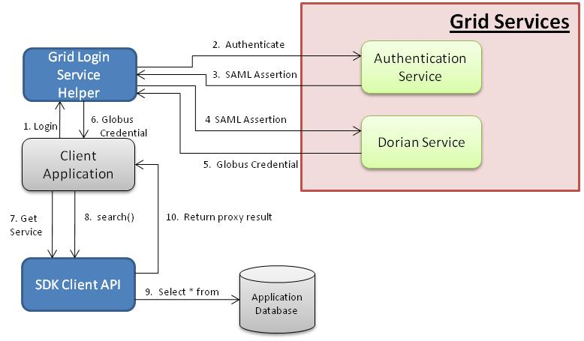
Figure 1 : Expected Behavior of SDK Generated Secured API Using Grid Credentials
The diagram above shows the expected behavior of the SDK generated secured application which can accept the Grid Proxy to authenticate and authorize the users. In order to interact with the SDK generated application, the client application follows the steps listed below. Steps 1-6 listed below allow the client application to obtain the Globus Credential. The client application can alternatively obtain the Globus Credential themselves and use it. Once the Globus Credential is obtained, the interaction with the SDK generated application is expected to behave in consistent fashion as described in step 7-10.
- Client application invokes into the Grid Login Service Helper module which can take user’s username and password as input and complete the authentication workflow to obtain the Grid Proxy for the user
- Grid Login Service Helper invokes into the Authentication Service to authenticate the user’s username and password
- Authentication Service returns SAML assertion to the Grid Login Service Helper indicating successful login
- Grid Login Service Helper invokes into Dorian Service with SAML assertion obtained in the earlier step
- Dorian validated the SAML assertion and returns the Globus Credential to the Grid Login Service Helper
- Grid Login Service Helper returns the Globus Credential to the client application
- Client application invokes into SDK with Globus Credential obtained earlier to acquire reference to the SDK generated service
- Client application invokes into the search method of the SDK’s service layer
- SDK performs authorization of the user and retrieves data from the database
- SDK returns the result set to the client application

Design
This section describes the implementation level details of the requirements listed in the requirements section. Initially it provides an overview of the different interfaces of the SDK generated system. Subsequently it provides details on how the business requirement is implemented across each interface of the SDK generated application. This section also provides more details on individual components used to achieve the final goal.

SDK Generated Application’s Interfaces
The SDK generated application allows access to the data using different mechanisms. Given below is the list of all the interfaces
- Remote client - Allows the client application to get data from the database via remote service
- Local client – Allows the client application to get data directly from the database using the API
- Web client – Allows the client to use browser based client to get the data from the database
- RESTful client – Allows the client to use thin client application to get data from the database
- Web service – Allows platform independent access to the data from the database

SDK’s Current Security Implementation
The caCORE SDK generated system currently provides security by leveraging two different technologies 1) ACEGI and 2) CSM. ACEGI framework for provides security framework which is capable of allowing users to configure security within their application. CSM on the other hand provides implementation of many of the security features like RDBMS and LDAP based JAAS login module, security configuration through User Provisioning Tool (UPT), instance level security etc. In SDK these two technologies have been integrated to provide comprehensive solution to the users’ needs.
The default implementation of the SDK security works on the username and password based authentication. SDK accepts username and password from the user through all of its interfaces as listed below
- Remote client – Provided when obtaining reference to the service API
- Local client – Provided when obtaining reference to the service API
- Web client – Provided through input dialog box on home page of web application
- RESTful client – Provided as BASIC authentication header
- Web service – Provided as SOAP header when calling the remote web service
Across all the interfaces generated by the SDK, the ACEGI framework intercepts the call through HTTP filter or through AOP based interceptors. Within ACEGI when the call is intercepted, ACEGI attempts to login the user based on the username and password combination using appropriate Authentication Provider. In SDK the default Authentication Provider is built as a bridge to the CSM. The diagram shown below provides high level interaction between the primary components involved in secured communication between remote client and web client with the remote server. Interaction of other types of clients with their corresponding interfaces is similarly implemented but not discussed here.
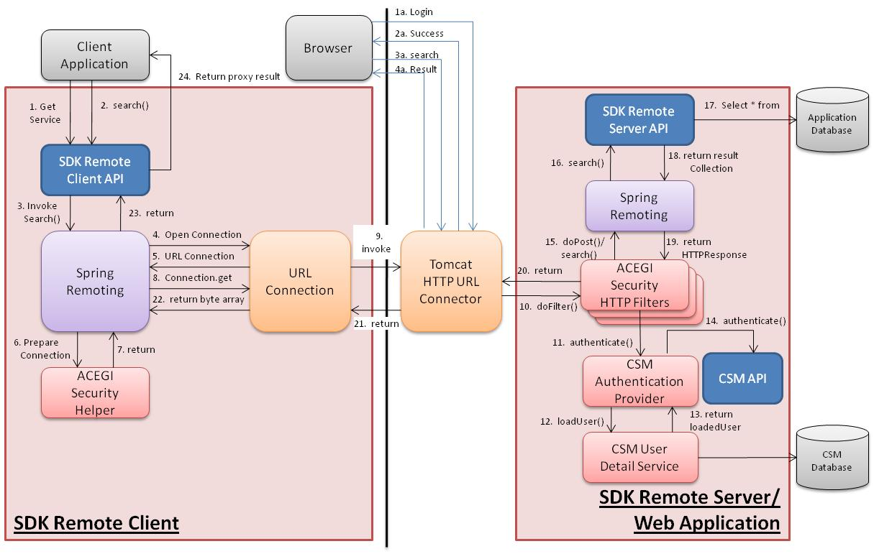
Figure 2 : SDK Generated Secured API with Username and Password

The steps listed below describes the workflow illustrated in the diagram above

- Client application invokes into SDK Remote Client API to obtain the handle to the remote service and passes username & password to be used during the course of communication
- Client application invokes into the Remote Client API to perform a business operation e.g. search()
- Remote client API delegates the call to the Spring Remoting
- Spring Remoting opens URL connection using Java’s Network library
- Java’s Network library returns the handle to a new URLConnection
- Spring Remoting extension passes URLConnection to the ACEGI Security Helper to add security headers
- ACEGI Security Helper returns the updates URLConnection with BASIC authentication header and returns to the Spring Remoting
- Spring Remoting invokes into the URLConnection to connect to the server and execute the operation
- URLConnection connects to the server using HTTP/HTTPS protocol and performs handshake.
- Tomcat HTTP Connector on the server side allows the control to be propagated to the host application which is intercepted by the ACEGI Security’s HTTP filter.
- The ACEGI filter chain retrieves the user’s username and password from the BASIC header and invokes in to the authentication provider to authenticate the user
- The CSM Authentication Provider invokes in the CSM User Detail service to load the user for the username
- The CSM User Detail Service returns the loaded user to the CSM Authentication Provider
- CSM Authentication Provider invokes into CSM API to authenticate the user which gets validated using JAAS based login module for CSM
- ACEGI Security Filter allows the user’s request to proceed to the appropriate servlet which in this case is Spring Remoting’s HTTP Service Exporter servlet
- Spring Remoting servlet retrieves the parameters from the request and invokes into the SDK’s Remote Server API. This call is intercepted by the security interceptors to ensure that user has access rights to execute the operation
- SDK’s API invokes in the database to retrieve the results for the user’s query
- SDK’s API returns the result to the Spring Remoting servlet
- Spring Remoting servlet prepares and return the HTTP response to the ACEGI security filter
- ACEGI security filter returns the response to the Tomcat’s HTTP Connector
- HTTP Connector returns the response to the URL Connection
- URL Connection returns the result in form of Byte stream to the Spring Remoting
- Spring Remoting converts the byte stream into the result set and returns it to the SDK’S remote client API
- SDK’s remote client API adds interceptor to the result set and returns the result to the client application

Proposed Solution
In SDK generated system the authentication and authorization is being performed in the back-end or the core of the application. All the interfaces produced by the SDK communicate with the back-end system using some kind of wrapper. For e.g. Web service clients talks to the web service wrapper which in-turn talks to the back-end system to execute the query. Depending on which interface user is using, a different mechanism is used to propagate the user’s credentials to the back-end system. The section 5.2 provides a list of credential propagation mechanism for username and password based credentials. Once the credentials are delivered to the back-end system, the authentication and authorization process remains the same for all the interfaces.
In the proposed design, the Globus Credential is treated as an additional way to specifying user’s credentials where authentication process just determines that the user is provisioned in the authorization schema or not. During the authorization process, the user’s Grid Identity as computed from the Globus Credentials will be used as a username.
The sections below provide more details on how the Globus Credential is being used in each interface of the SDK generated application. In case of the API, the user provides the Globus Credential by retrieving it from the Dorian service. The SDK generated API propagates the Globus Credential to the server in secured fashion. In the case of all other interfaces, the user provides the username and password to the SDK generated system and SDK performs the authentication against the grid and retrieves their Globus Credential.
Once the Globus Credential reaches the back-end, the ACEGI based implementation recognizes the type of the credentials and switches to different authentication provider to validate the user. Having different authentication provider based on the credential type allows the SDK generated system to be backwards compatible with the existing implementation.

Known Limitations
The proposed solution uses the Grid Identity computed from the Globus Credential for authorization purpose against the CSM schema/API. Since SDK performs authorization using CSM, the user’s authorization policy as specified in the Grid Grouper will not be used in any manner.

Remote Client API
The SDK generated remote client API allows the client application to get to the data in the database via a SDK generated remote server API. From the remote client’s perspective there are two primary objectives when the users of the starts using the Globus Credential obtained from the caGrid. The objectives are 1) securing the communication channel and 2) propagating the user’s Grid Identity to the server so that it can be used for authorization purpose.
There are different ways to implement the requirements that the remote client API is needed to implement. One way to implement the requirement is to create a dynamic Trust Store and dynamic Key Store. The trust store and the key store needs to be dynamic as the user can pass different Globus Credential each time and the client API will need to provide it to the server each time it opens the connection.
In the proposed design, the dynamic Trust Store and Key Store management is achieved by using the extended GSI library. The extended GSI library allows opening the secure URL connection to the server using Globus Credential. When used for the first time, the URL connection exchanges the user’s temporary X509 certificate (contained in Globus Credential) with the server using SSL handshake protocol. By using this approach, we can achieve the first objective of securing the channel using client’s credential.
On the server side, we have enabled GSI HTTPS connector to establish SSL which is part of the Globus GSI library. This connector also obtains the client’s certificate and sets as parameter in the HTTP request when accepting the connection from the client. The SDK generated application can retrieve the user’s Grid Identity using the information obtained from the HTTP Request and perform authorization. The diagram given below describes the primary steps involved in achieving the functionality discussed earlier in this subsection.
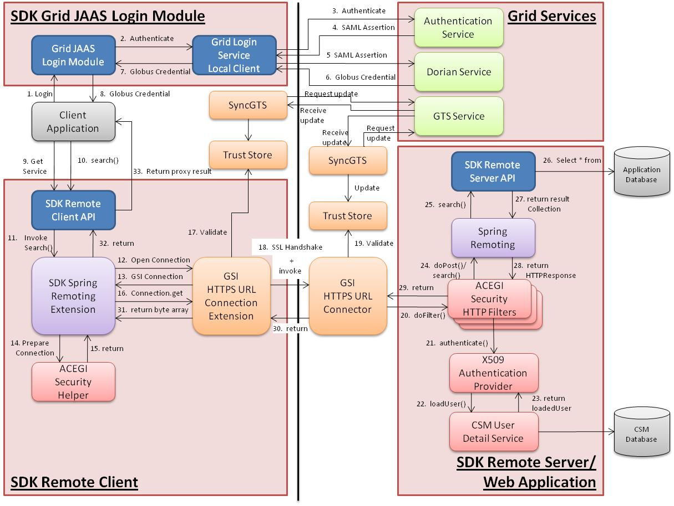
Figure 3 : SDK Generated Secured Remote API with Grid Credential
Note: Steps 1-8 listed below are required to obtain the Globus Credential which the client application can perform in alternate way. Steps 1-8 listed here achieve the same functionality as steps 1-6 listed in the business view section earlier. Steps 9-33 achieve same functionality as step 7-10 listed in the business view section.
- Client application invokes into the Grid JAAS Login module which can take user’s username and password as input and complete the authentication workflow to obtain the Globus Credential for the user
- Grid JAAS login module invokes into Grid Login Service’s Local client implementation to authenticate user and obtain Globus Credential
- Grid Login Service client invokes into the Authentication Service to authenticate the user’s username and password
- Authentication Service returns SAML assertion to the Grid Login Service client indicating successful login
- Grid Login Service client invokes into Dorian Service with SAML assertion obtained in the earlier step
- Dorian validated the SAML assertion and returns the Globus Credential to the Grid Login Service client
- Grid Login Service client returns the Globus Credential to the Grid JAAS login module
- Grid JAAS login module returns the Globus Credential to the client application
- Client application invokes into SDK Remote Client API to obtain the handle to the remote service and passes Globus Credential to be used during the course of communication
- Client application invokes into the Remote Client API to perform a business operation e.g. search()
- Remote client API delegates the call to the SDK’s Spring Remoting extension
- SDK’s Spring Remoting extension opens HTTPS connection using GSI library when it detects that the client is using Globus Credential
- GSI HTTPS URL connection returns the handle to a new HTTPS URLConnection
- SDK’s Spring Remoting extension passes URLConnection to the ACEGI Security Helper to add security headers
- ACEGI Security Helper returns the updated URLConnection to the Spring Remoting Extension
- Spring Remoting Extension invokes into the GSI HTTPS URLConnection to connect to the server and execute the operation
- GSI HTTPS URLConnection validates the server certificate during the handshake
- GSI HTTPS URLConnection connects to the server using SSL protocol and completes handshake. During the handshake, the client’s temporary certificate from the Globus Credential is exchanged with the server which server sets in the HTTP Request under GSI Context after performing validation
- GSI Connector validates the client’s Globus Credential against the trust store
- GSI Connector on the server side allows the control to be propagated to the host application which is intercepted by the ACEGI Security filter.
- The ACEGI filter chain retrieves the user’s temporary X509 certificate from the GSI Context and invokes into X509 Authentication Provider to validate the user corresponding to the certificate.
- The X509 Authentication Provider computes the user’s Grid Identity from the X509 Certificate and invokes in the CSM User Detail service to load the user for the Grid Identity
- The CSM User Detail Service returns the loaded user to the X509 Authentication Provider
- ACEGI Security Filter allows the user’s request to proceed to the appropriate servlet which in this case is Spring Remoting’s HTTP Service Exporter servlet
- Spring Remoting servlet retrieves the parameters from the request and invokes into the SDK’s Remote Server API. This call is intercepted by the security interceptors to ensure that user has access rights to execute the operation
- SDK’s API invokes in the database to retrieve the results for the user’s query
- SDK’s API returns the result to the Spring Remoting servlet
- Spring Remoting servlet prepares and return the HTTP response to the ACEGI security filter
- ACEGI security filter returns the response to the GSI HTTP Connector
- GSI HTTP Connector returns the response to the GSI HTTPS URL Connection
- GSI HTTPS URL Connection returns the result in form of Byte stream to the SDK’s spring Remoting extension
- SDK’s Spring Remoting extension converts the byte stream into the result set and returns it to the SDK’S remote client API
- SDK’s remote client API adds interceptor to the result set and returns the result to the client application
Note: While the client and server are conversing, the SyncGTS daemon is running in the background which updates the trust store with the CA’s public certificate against which the GSI library performs the validation for counterparty’s credentials

Local Client
The SDK generated local client API allows the client application to get to the data in the database directly without any additional network overhead. From the local client’s perspective the primary objective is to use the user’s Grid Identity for authorization purpose when the user start using the Globus Credential obtained from the caGrid.
In the proposed design, the user passes Globus Credential to the SDK generated local API when obtaining the handle to the service API. When the user attempts to invoke in the secured API, the security filter log the user in the application using X509 Authentication Provider. Once the user is logged-in, the SDK generated application can authorize the user against CSM schema to determine if the user has access rights to execute specific operation or not. The authorization process here is same as the SDK’s regular security authorization which determines access rights based on the username which in this case is converted to the user’s Grid Identifier.
The diagram given below describes the primary steps involved in achieving the functionality discussed earlier in this subsection.
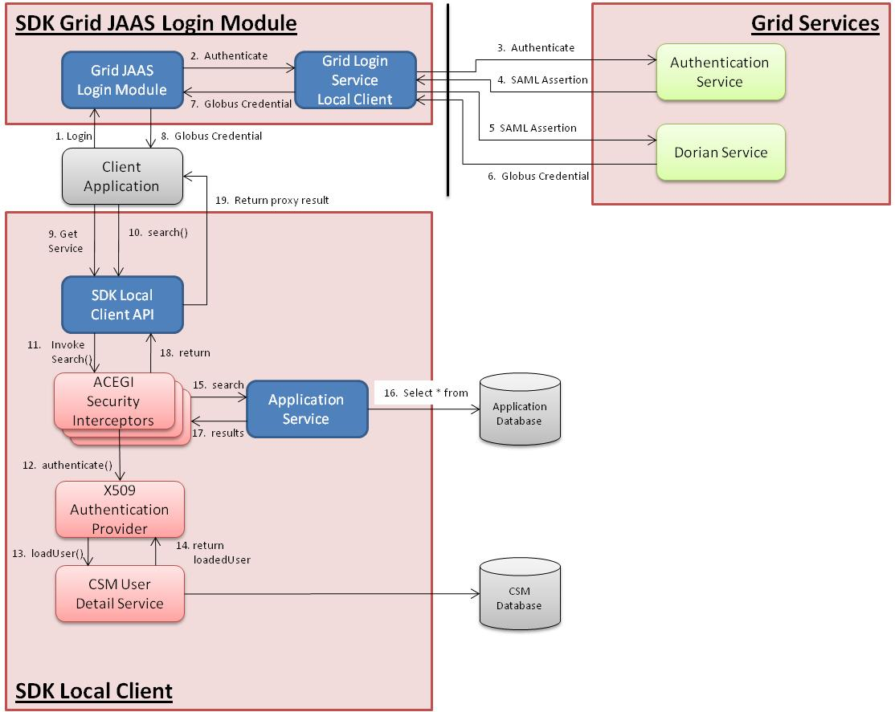
Figure 4 : SDK Generated Secured Local API with Grid Credential
Note: Steps 1-8 listed below are required to obtain the Globus Credential which the client application can perform in alternate way. Steps 1-8 listed here achieve the same functionality as steps 1-6 listed in the business view section earlier. Steps 9-19 achieve same functionality as step 7-10 listed in the business view section.
- Client application invokes into the Grid JAAS Login module which can take user’s username and password as input and complete the authentication workflow to obtain the Globus Credential for the user
- Grid JAAS login module invokes into Grid Login Service’s Local client implementation to authenticate user and obtain Globus Credential
- Grid Login Service client invokes into the Authentication Service to authenticate the user’s username and password
- Authentication Service returns SAML assertion to the Grid Login Service client indicating successful login
- Grid Login Service client invokes into Dorian Service with SAML assertion obtained in the earlier step
- Dorian validated the SAML assertion and returns the Globus Credential to the Grid Login Service client
- Grid Login Service client returns the Globus Credential to the Grid JAAS login module
- Grid JAAS login module returns the Globus Credential to the client application
- Client application invokes into SDK Local Client API to obtain the handle to the local service and passes Globus Credential to be used during the course of communication
- Client application invokes into the Local Client API to perform a business operation e.g. search()
- Local client API delegates the call to the SDK’s service API i.e Application Service but it is intercepted by ACEGI sercurity interceptor
- The ACEGI security interceptor retrieves the user’s temporary X509 certificate from the X509 Authentication Token and invokes into X509 Authentication Provider to validate the user corresponding to the certificate
- The X509 Authentication Provider computes the user’s Grid Identity from the X509 Certificate and invokes in the CSM User Detail service to load the user for the Grid Identity
- The CSM User Detail Service returns the loaded user to the X509 Authentication Provider
- ACEGI Security interceptor allows the user’s request to proceed to the Application Service
- Application Service invokes in the database to retrieve the results for the user’s query
- Application Service returns the result to the ACEGI security interceptor
- ACEGI security interceptor returns the result to the client API
- SDK’s local client API adds interceptor to the result set and returns the result to the client application

Web Client
The web client application generated by the SDK allows the user to build and execute query against the database. When the security is enabled in SDK generated application the web interface prompts the user to enter his username and password so that the web application can authenticate the user and allow user to access the data in secured manner.
In order to allow the user to use their username and password, and authenticate them against the caGrid authentication service one has to implement the authentication workflow. There are currently two ways to implement the requirement 1) Use Single Sign On kind of login mechanism as implemented by WebSSO which can accept user’s username and password, and return user’s grid proxy 2)Implement the authentication workflow in SDK and obtain the grid proxy by executing authentication workflow
In this document we are proposing implementing the second alternative because 1) it requires simpler installation and 2) the SDK generated systems are normally deployed as independent applications unlike the grid services. The remainder of this subsection describes the implementation details of the suggested alternative.
In the current security implementation of SDK, the user provides username and password to the SDK generated application. The SDK’s web application passes the username and password through ACEGI security framework and CSM to the JAAS based login module so that the authentication can be performed. Subsequent to the authentication, the ACEGI and CSM based security implementation in SDK uses user’s username for the authorization purpose.
Since the traditional JAAS based security implementation uses same username for authentication and authorization purpose, an alternate implementation needs to be created which uses the user’s username for the authentication purpose and uses user’s Grid Identity for authorization purpose. In our suggested approach a JAAS based authentication module has been created which can take user’s username and password as input and perform grid’s authentication workflow to obtain the Globus Credential. Subsequently, the login module returns the JAAS subject populated with the Globus Credential as a Principal. SDK’s security implementation retrieves the Globus Credential from the JAAS subject to calculate the user’s Grid Identity which can be used for the authorization purpose.
The SDK’s Grid JAAS Login Module which connects to the grid service to execute authentication workflow depends on the Axis 1.2 libraries. At the same time, the SDK uses Axis 1.4 for generating its own web service. Since having two different versions of the same set of libraries in the classpath causes conflict, they are required to be kept in separate environment. In order to separate the libraries one need to implement a custom classloader which can load these libraries in separate environment. The application server provides an implementation of the classloader in the form of web application loader where each web application is loaded in its own environment. The proposed solution leverages the web application loader where the authentication workflow has been separated in a new web application which can be accessed using Spring Remoting based remote client implementation.
The following diagram describes the grid security workflow implementation as proposed earlier in the subsection
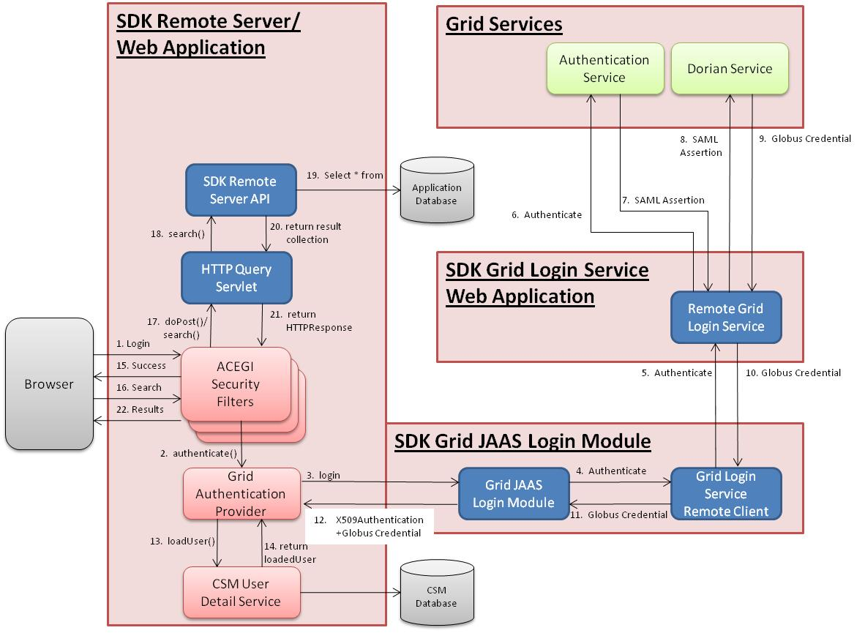
Figure 5 : SDK Generated Secured Web Interface with Grid Credential
- Client attempts to invoke into SDK generated secured application by providing his username and password on the home page of the web interface
- The ACEGI filter chain receives the user’s request and invokes into Grid Authentication Provider to validate the user’s credentials
- The Grid Authentication Provider locates and invokes the Grid JAAS login module which can take user’s username and password as input and complete the authentication workflow to obtain the Globus Credential for the user
- Grid JAAS login module invokes into Grid Login Service’s Remote client implementation to authenticate user and obtain Globus Credential
- Grid Login Service remote client invokes into the remote login service to authenticate user and obtain Globus Credential
- Grid remote login service invokes into the Authentication Service to authenticate the user’s username and password
- Authentication Service returns SAML assertion to the Grid Login Service client indicating successful login
- Grid remote Login Service invokes into Dorian Service with SAML assertion obtained in the earlier step
- Dorian validated the SAML assertion and returns the Globus Credential to the Grid remote Login Service
- Grid remote Login Service returns the Globus Credential to the Grid Login service remote client
- Grif login service remote client returns Globus Credential to the Grid JAAS login module
- Grid JAAS login module returns the Globus Credential to the Grid Authentication Provider
- The Grid Authentication Provider computes the user’s Grid Identity from the X509 Certificate and invokes in the CSM User Detail service to load the user for the Grid Identity
- The CSM User Detail Service returns the loaded user to the Grid Authentication Provider
- ACEGI Security filter chain returns success page to the client’s browser after setting the authentication token in the session
- Client builds the search query and sends it to the server to retrieve the result
- ACEGI security filter chain retrieves the user’s authentication token from the session and allows the user’s request to be forwarded to the HTTP Query servlet
- HTTP Query servlet retrieves the parameters from the request and invokes into the SDK’s Remote Server API. This call is intercepted by the security interceptors to ensure that user has access rights to execute the operation
- SDK’s API invokes in the database to retrieve the results for the user’s query
- SDK’s API returns the result to the Spring Remoting servlet
- HTTP Query servlet prepares and return the HTTP response to the ACEGI security filter
- ACEGI security filter returns the response page to the browser

RESTful Client
The RESTful service provided by the SDK generated application uses the same login mechanism as the web interface provided. As a result, the RESTful service users can access the SDK generated application with grid based authentication in the same manner as CSM based authentication already provided in the current security implementation in SDK.

Limitation
Since the RESTful service users passes the username and password on each request to the SDK generated application, the SDK performs authentication for them before processing the request.
Note: The re-authentication of the user against the grid service causes the performance delay for each request.

Web Service
The Web Service provided by the SDK generated application takes the username and password as part of the web service. This header is processed with help of a custom header processor and ACEGI based authentication manager. As the authentication manager used by the web application is the same as the web service authentication manager, no additional coding is needed. As a result, the Web Service users can access the SDK generated application with grid based authentication in the same manner as CSM based authentication already provided in the current security implementation in SDK.

Limitation
Since the Web Service users passes the username and password on each request to the SDK generated application, the SDK performs authentication for them before processing the request.
Note: The re-authentication of the user against the grid service causes the performance delay for each request.

Generation/Deployment Consideration
This section contains the details about 1) the SDK’s system generation settings 2) deployment of the generated artifacts and 3) server configuration.

<<To be completed later>>

SDK system generation settings

Grid Services properties

Security properties

Server Configuration

Installing additional libraries in the server

Installing GSI connector

Deploying web application components

Login module configuration

Starting SyncGTS

Firewall rules

Client Configuration

Choosing and installing the client

Installing SDK-Grid JAAS login module/Login Module Configuration

Starting SyncGTS

CSM Security Configuration

Login ID migration

Future Consideration

Axis Versions harmonization
The proposed solution of the SDK system performing grid authentication through a remote web application is a temporary solution till the Axis versions of caGrid and SDK are harmonized. Once the Axis versions are harmonized, there will be no need to host a secondary web application and it can be easily replaced by means of changing the Spring based configuration file to point to the local implementation instead of remote service.

Discovery of Authentication service and Allowing user to specify Authentication Service
The proposed design relies on static configuration of the authentication service and dorian service. In the caGrid environment there can be multiple instances of the authentication services which can be added at later time. The SDK needs to leverage this functionality. In order to implement this, the SDK’s login process needs to prompt user to specify which specific authentication service to be used to authenticate the user. The list of authentication service can be made available by static configuration file or the discovery API of the caGrid.

Technology Stack

Technology | Versions
Java | JDK 1.5.0_10
Application Server | JBoss 4.0.5, Tomcat 5.0.28
Database Server | Oracle 9.2.0.6, MySQL 5.0.27

Acronyms/Definitions

No | Acronym | Definition
1 | Domain Model | UML object model of the application representing the application’s data
2 | Authentication | Determining if the user’s credentials are valid
3 | Authorization | Determining if the valid user has access to certain resource
4 | CSM | Common Security Module – A tool to manage security of an application
5 | caGrid | Collection of tools to create federation of the data sources as web services
6 | LDAP | Protocol to gain access to the corporate user accounts
7 | JAAS | Standard to configure security in the J2EE environment
8 | RDBMS | Relational database like Oracle or MySQL
9 | Dorian | A caGrid service to issue temporary X509 certificate for the user
10 | Authentication Service | A caGrid service which authenticates the user based on username and password
11 | X509 Certificate | A digital certificate representing user’s public key
12 | IDP | A source of user accounts
13 | Grid Proxy | Globus Credential object which contains user’s authenticated information
14 | Globus Credential | An object which contains user’s authenticated information
15 | GSI | Grid Security Infrastructure module in the Globus toolkit
16 | Grid Identity | Issuer DN in the X509 Certificate as computed by the Bounty Castle
17 | SSL | Secure Socket Layer – A transport layer protocol to encrypt the communication between two parties
18 | Trust Fabric | An environment where each node or service is trusted
19 | SAML | A token representing authenticated user’s credentials
20 | Trust Store | A data source containing public key of the trusted servers to which the client can connect
21 | Key Store | A data source containing public key and private key of the client
22 | BASIC Authentication | Authentication mechanism where user’s username and password are sent over HTTP headers in encrypted format
23 | Remoting | Remote communication protocol between client and server
24
25

